Some features of the SADAD Support Tool

Current available features

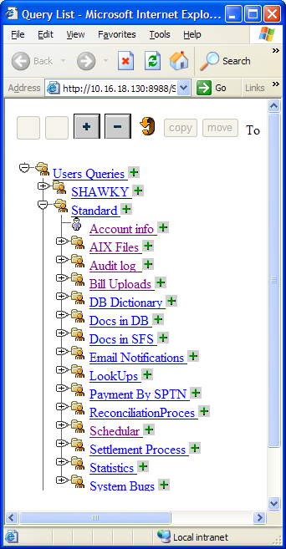 | Subsystem | Brief Description
 | Account info | To trace any problem knowing Biller and account no.
 | AIX Files | To browse AIX files ( log and configuration)
 | Audit log | To check audit logs in DB
 | Bill Upload | To Check Biller’s Bill Upload processes
 | Docs in DB | To check all online messages with any partner ( link PVALRQ)
 | Docs in SFS | To check all offline message with any partner (Like BULDRQ)
 | Lookups | To read any lookup table (like organization table)
 | Payment by SPTN | To Trace any problem knowing SPTN number
 | Reconciliation Process | investigate the status of the Reconciliation process
 | Schedular | To check the status of any scheduled task
 | Settelement Process | check the intra-bank settlement process
 | Statistics | Contains a list of useful statistics

Subsystems Details

1- Scheduler System

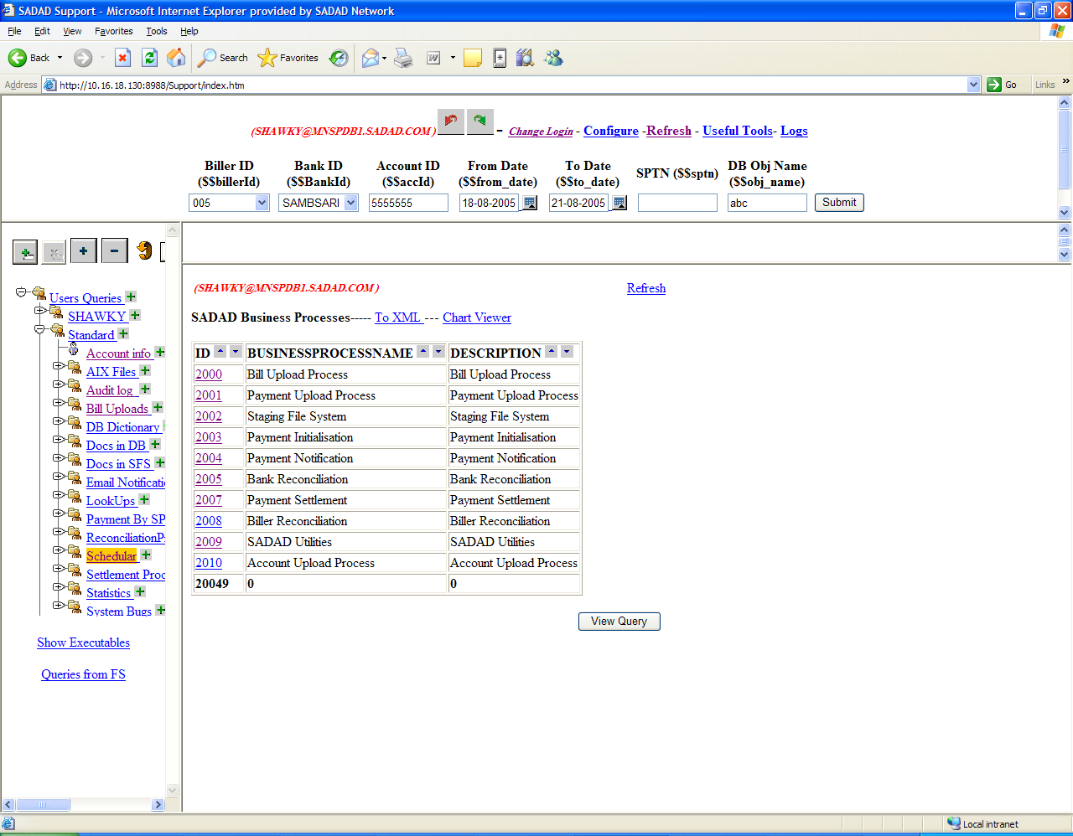

- select scheduler from the left bane tree
- a list of all sadad business processes will be displayed
- click on any one of them (for example Bank Reconciliation)
- A new window will be opened showing all the tasks associated with the selected business process, as the following
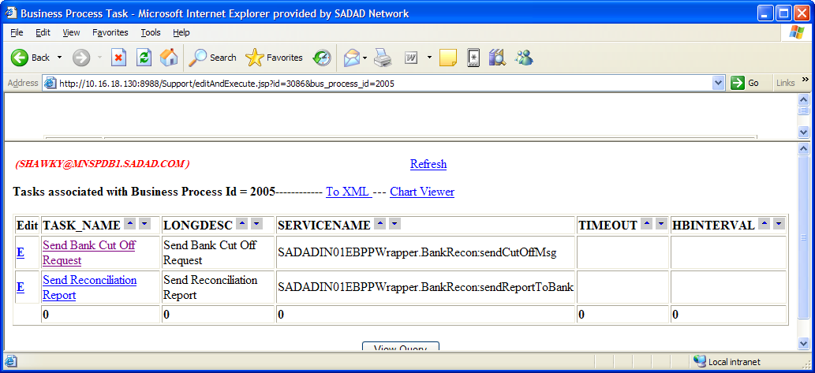

- Click on any task name (for example Send Bank Cutoff Request)

- A new window will open displaying all the scheduled events for the selected task

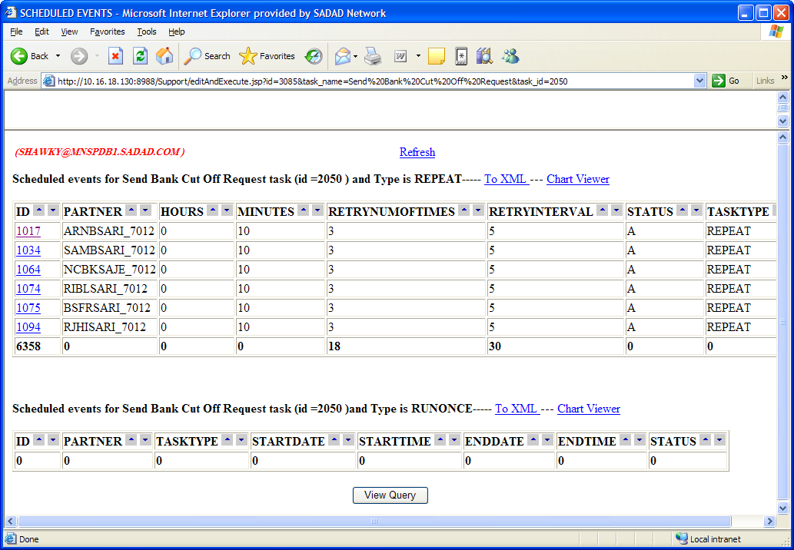

- Click on any event ID (for example SAMBSARI_7012) a list of logs for the selected event will be displayed indicating start and end time , status and a link to the Audit log for each scheduled task run
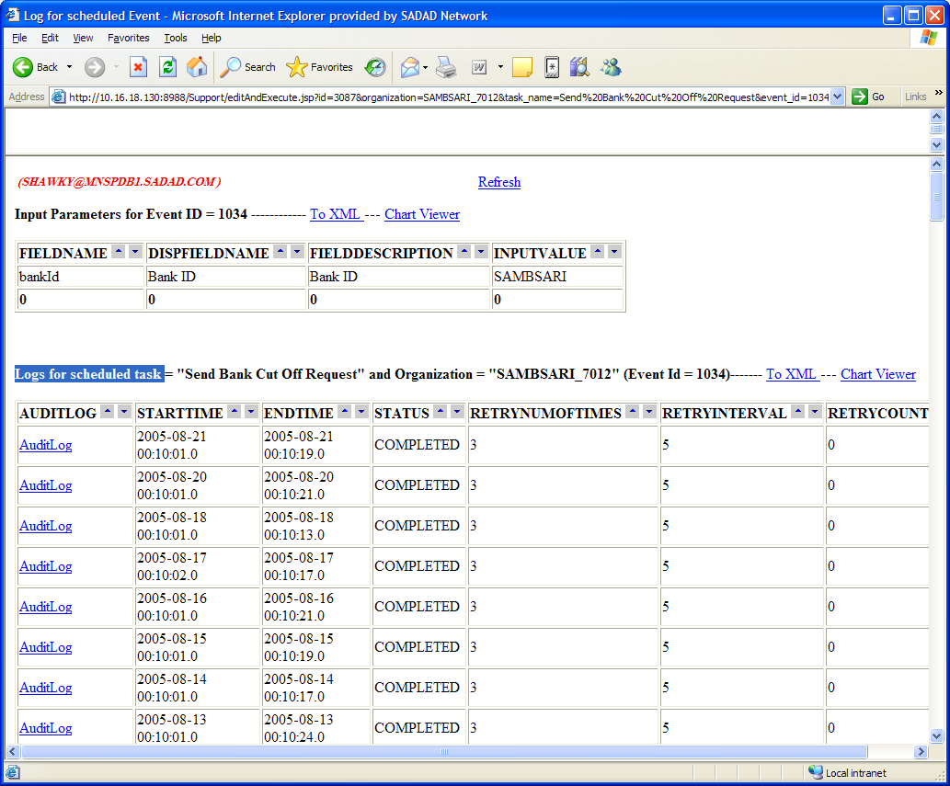

- Click on audit log link, a list of all audit log actions for the selected task occurred during the start and end time will be displayed.

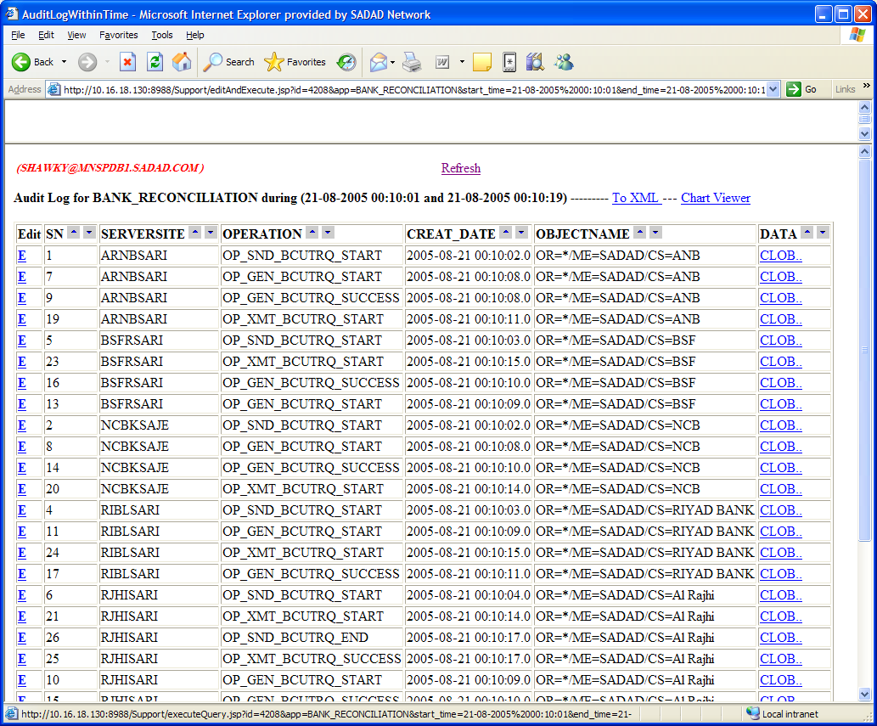

2- Tracing System Bugs
System can be easily configured to trace the occurrence of any system bug
(currently configured to trace payment mismatch and payment upload bugs )
And sends automatically a notification mail to the concerned persons

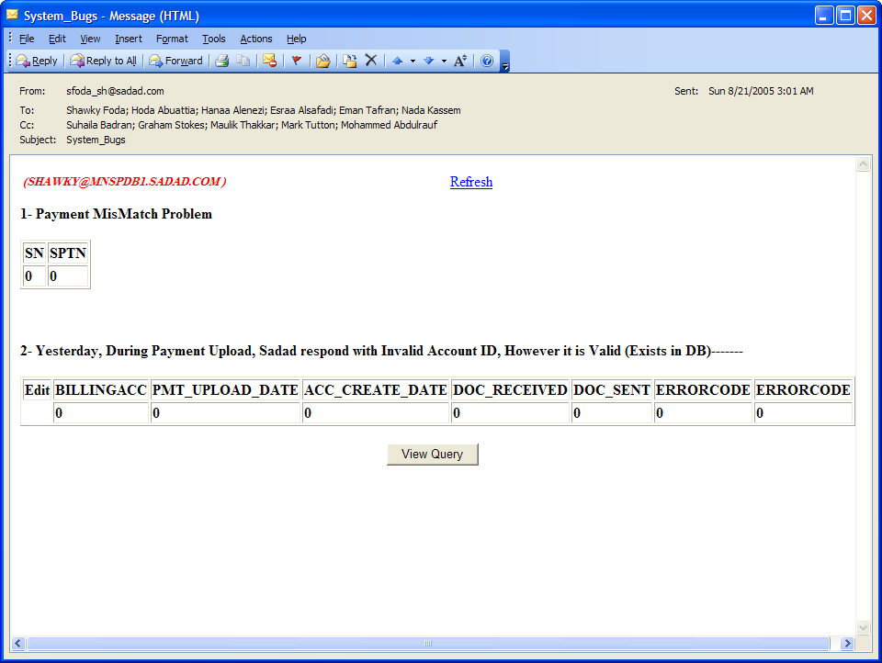

3- Daily Reports
System also can configured to send daily reports to concened persons (active mail report i.e. click on any link to display details)
For example:
Samba Bank Reconciliation notification mail

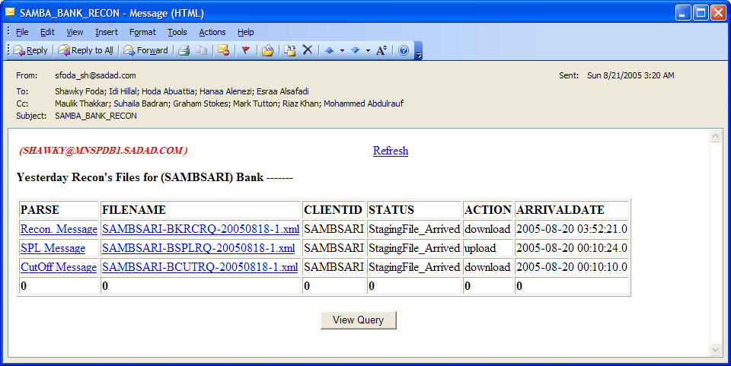

Click on Cutoff message for display
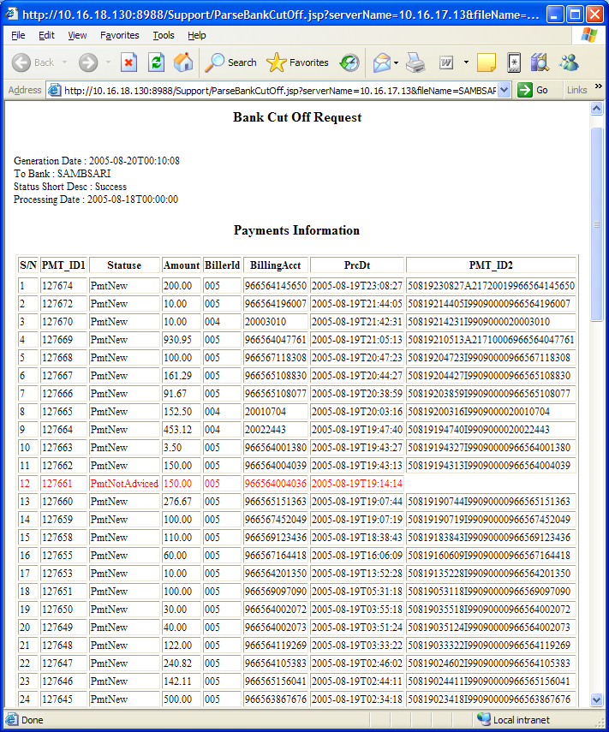

As indicated any error in the report will be displayed in red color so it is very easy and fast way to check the process.

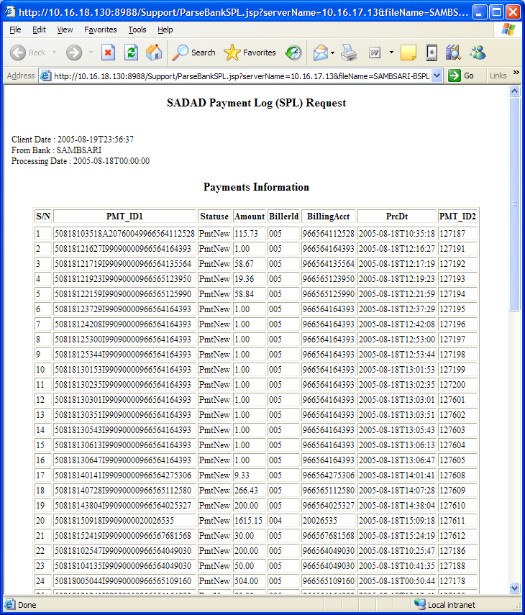

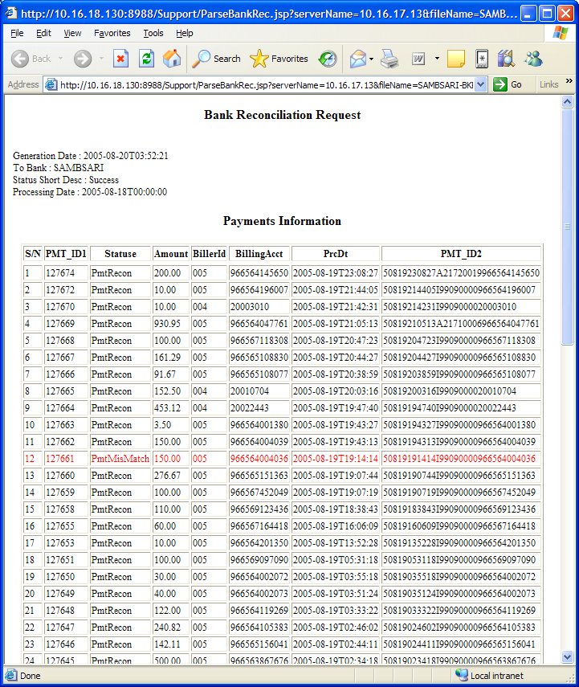

Payment statistics
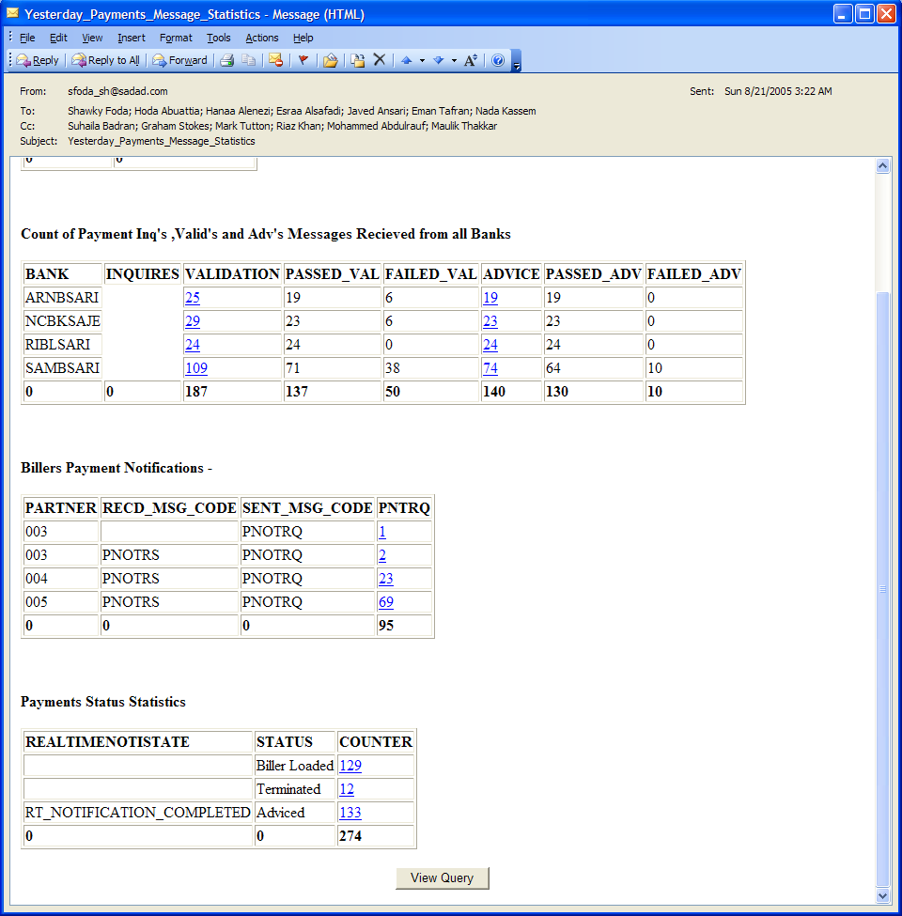
4- Check Free Log Files reader

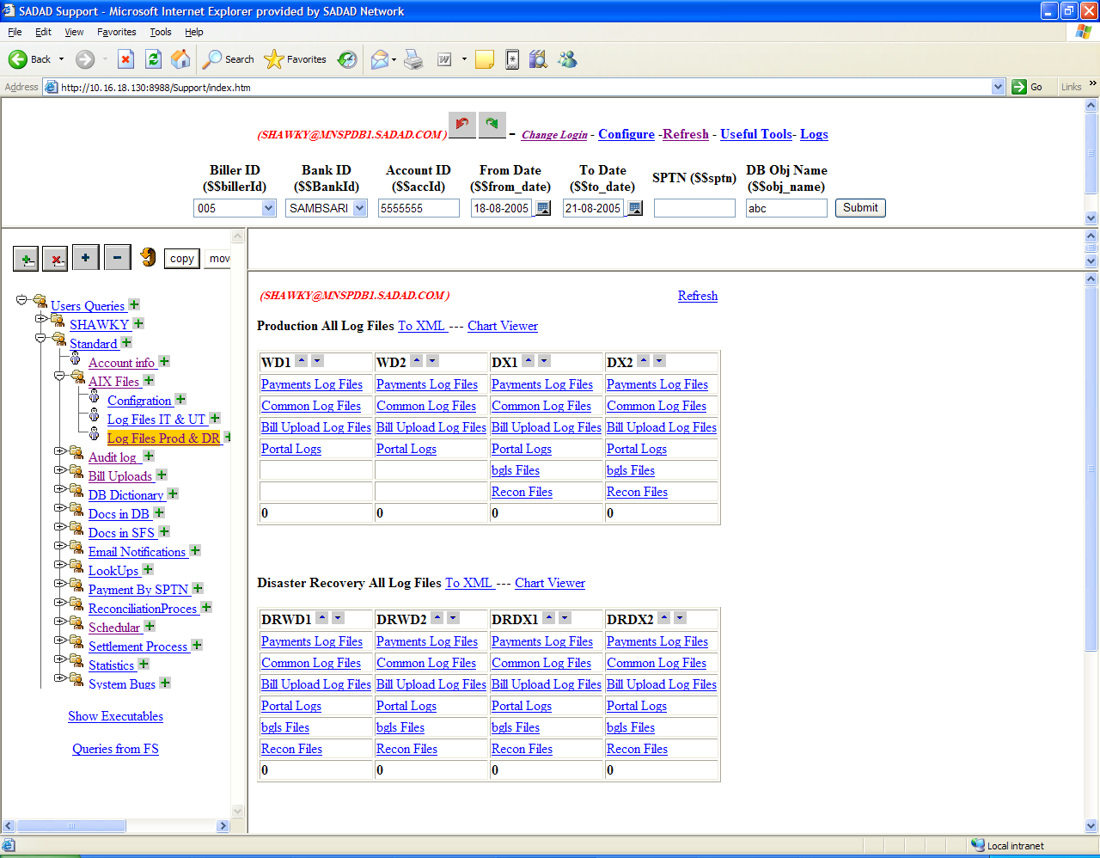
You can access all sadad servers (WD1 , WD2 , DX1 , DX2) from one screen
Click on any link (for example payment log Files @WD1) display a list of all the files at that server
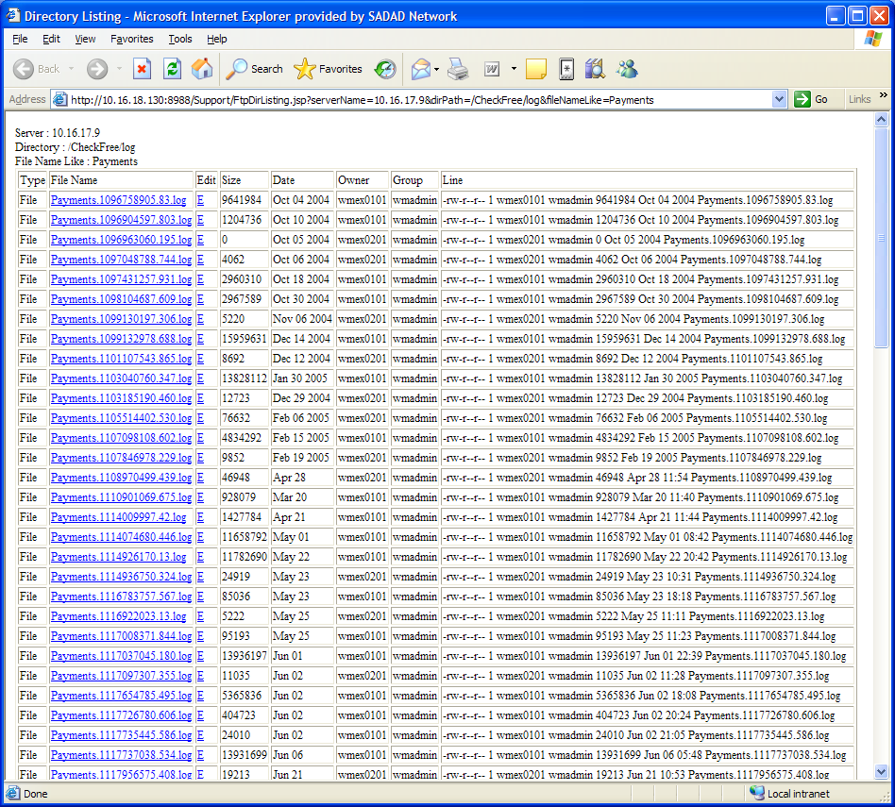

Click on any file name to read the file according to check free log format.
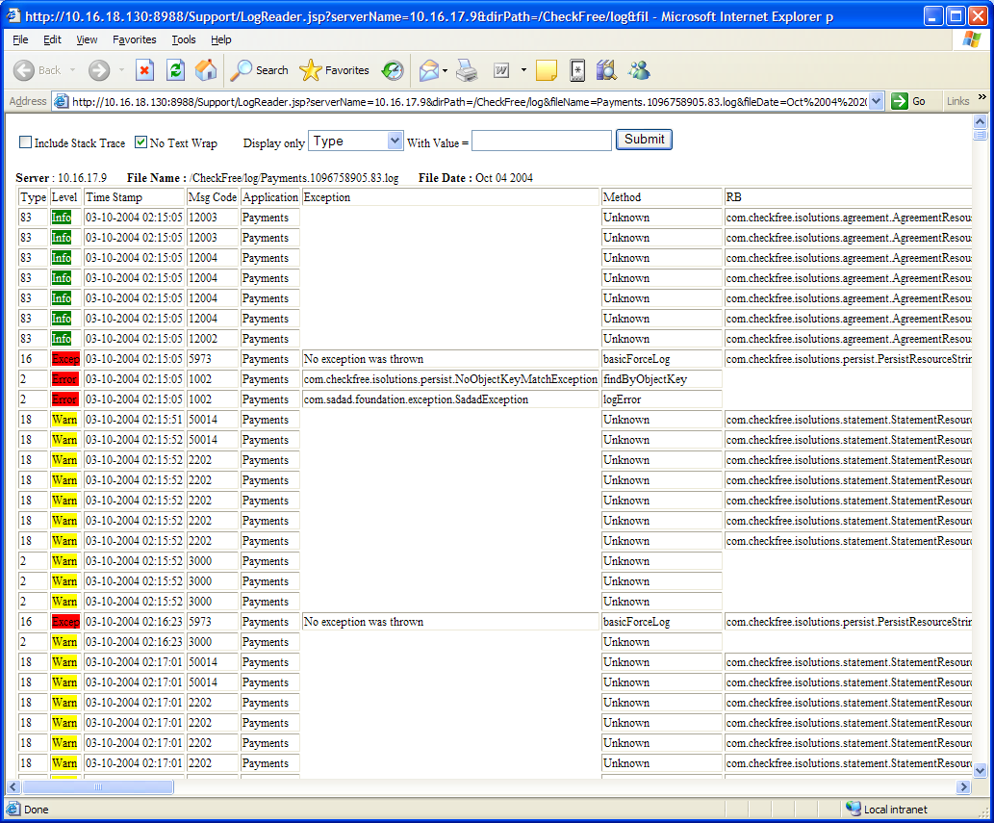

Note : This process was previously very long where user should first connect to the server using FTP, then download the file to his local machine then open this file using checkfree log reader client application. (user should install it on his machine)
With this approach
- Accessing this files is very fast
- No application needed to be installed on client machine.
- In addition it has more search features.
- Client use a single application (trying to integrate every thing in one application)
- Accessing all servers on all environments

- SADAD Configuration files
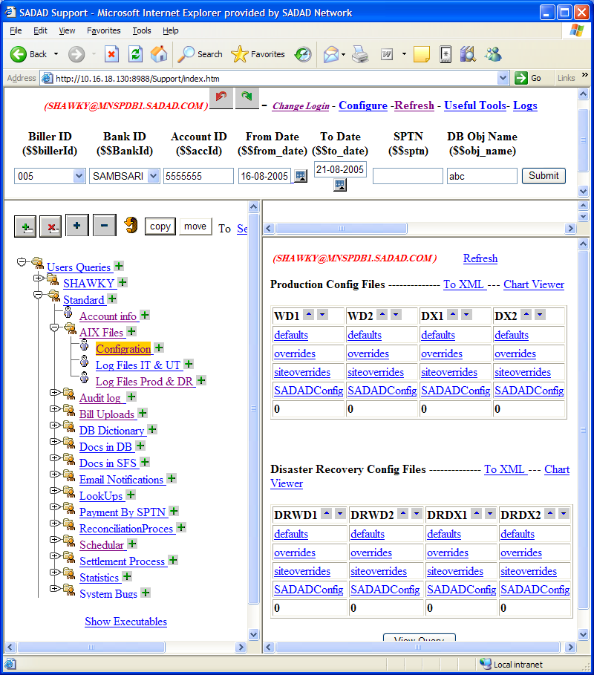
User can access sadad configuration files on any serevr (if he has access ) . click on any link to display a list of corresponding file type (for example : siteoverrides)

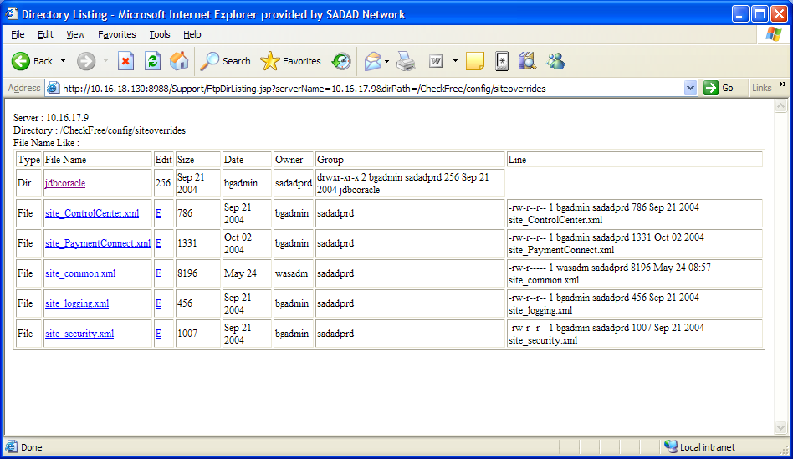

Click on any file to open it (for example site_logging.xml )
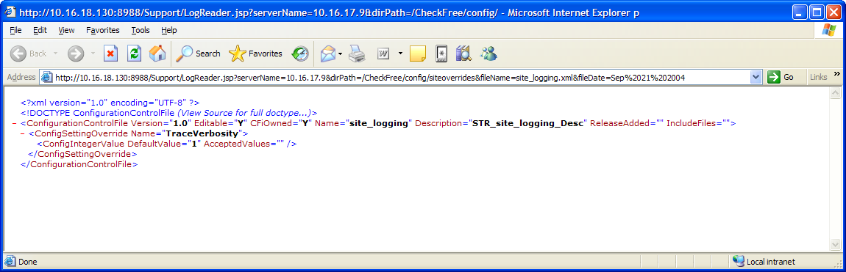

- Intra Bank Settlement

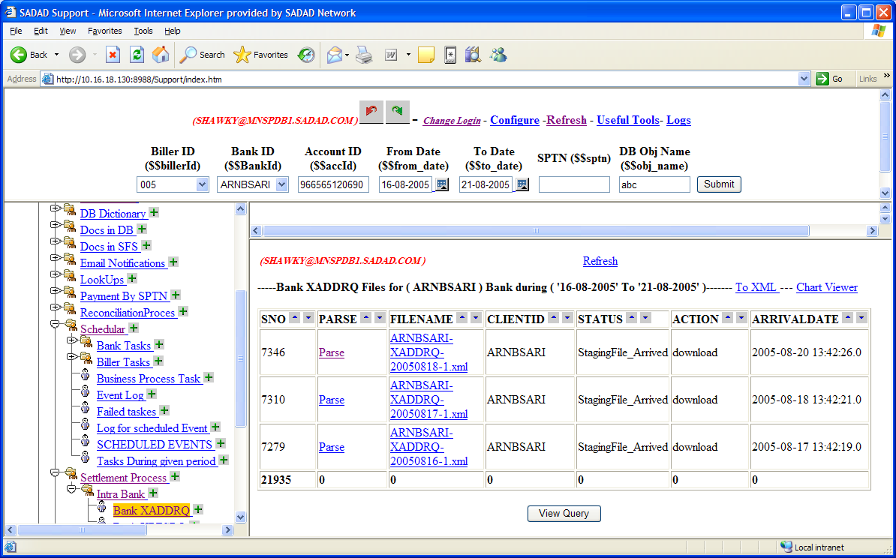
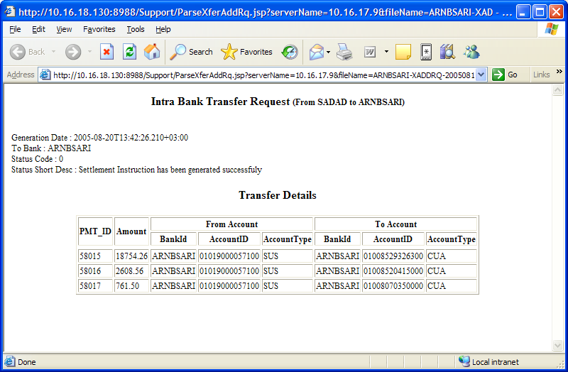

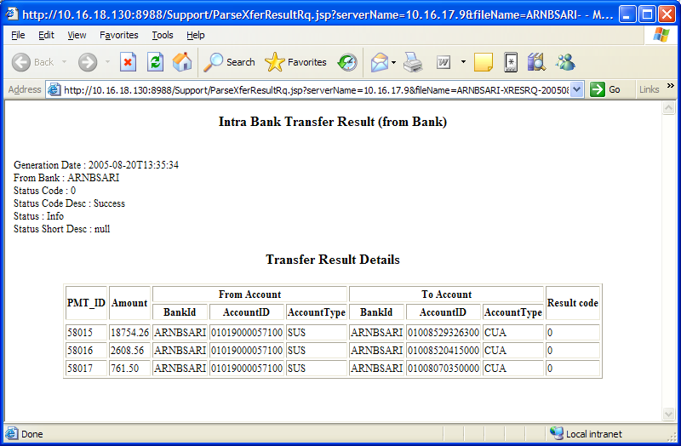

- Sarie request File

